Ben Brandhorst

CMIS 242

May 10th, 2019

**Project 4  
Manage A Student Database**

|  |  |  |  |
| --- | --- | --- | --- |
| **INPUT** | **EXPECTED OUTPUT** | **ACTUAL OUTPUT** | **PASS??** |
| **Id:** 1 **Name:** Ben Brandhorst  **Major:** Software Dev & Security  **Choose Selection:** Insert | **JOptionPane:”** Student record added to database” | **JOptionPane:”** Student record added to database” | YES |
| **Id:** 1 **Name:** Ben Brandhorst  **Major:** Software Dev & Security  **Choose Selection:** Update **Choose Grade:** B **Choose credits:** 6 | **JOptionPane:”** Choose Grade”  **JOptionPane:”** Choose credits”  **JOptionPane:”** Record Updated” | **JOptionPane:”** Choose Grade”  **JOptionPane:”** Choose credits”  **JOptionPane:”** Record Updated” | YES |
| **Id:** 1 **Name:** Ben Brandhorst  **Major:** Software Dev & Security  **Choose Selection:** Find | **JOptionPane:”** Student Name: Ben Brandhorst Major: Software Dev & Security Grade Point Average: 3.0” | **JOptionPane:”** Student Name: Ben Brandhorst Major: Software Dev & Security Grade Point Average: 3.0” | YES |
| **Id:** 1 **Name:** Ben Brandhorst  **Major:** Software Dev & Security  **Choose Selection:** Delete | **JOptionPane:”** Student record deleted” | **JOptionPane:”** Student record deleted” | YES |
| **Id:** p **Name:** Fake Name  **Major:** Beer  **Choose Selection:** Insert | **JOptionPane:”** Please use a whole number for the Id field” | **JOptionPane:”** Please use a whole number for the Id field” | YES |
| **Id:** 2 **Name:** Joe  **Major:** Journalism  **Choose Selection:** Delete | **JOptionPane:”** The selected Id was not found. Please try again.” | **JOptionPane:”** The selected Id was not found. Please try again.” | YES |
| **Id:** 2 **Name:** Joe  **Major:** Journalism  **Choose Selection:** Update | **JOptionPane:”** Student Id not found. Please try again.” | **JOptionPane:”** Student Id not found. Please try again.” | YES |
| **Id:** 007 **Name:** James Bond  **Major:** Spying  **Choose Selection:** Find | **JOptionPane:”** The selected Id was not found. Please try again.” | **JOptionPane:”** The selected Id was not found. Please try again.” | YES |
| **Id:** 123 **Name:** ABC  **Major:** Software Testing  **Choose Selection:** Insert | **JOptionPane:”** The selected Id already exists in the database. Please choose another.” | **JOptionPane:”** The selected Id already exists in the database. Please choose another.” | YES |

**Test Case 1 Output Example: (Insert)**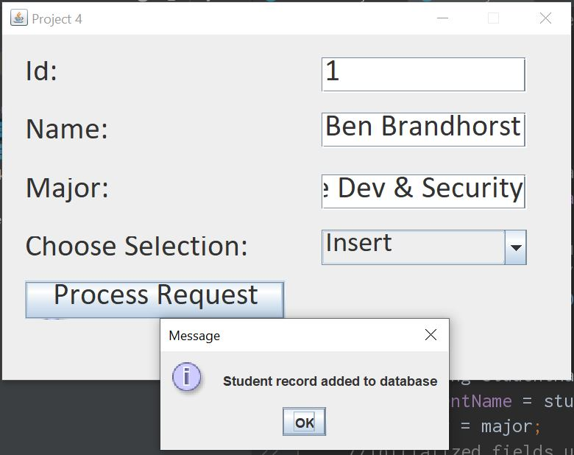

**Test Case 2 Output Example: A (Update)**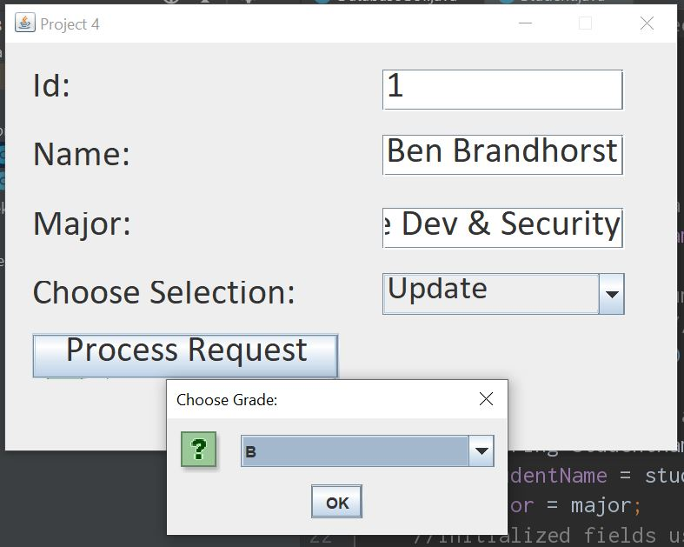

**Test Case 2 Output Example: B (Update)**

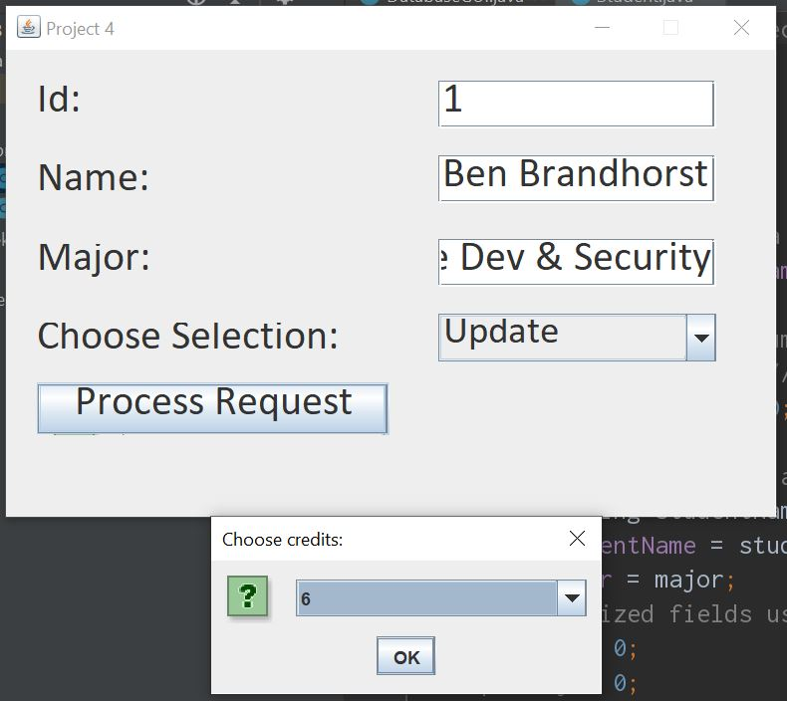

**Test Case 2 Output Example: C (Update)**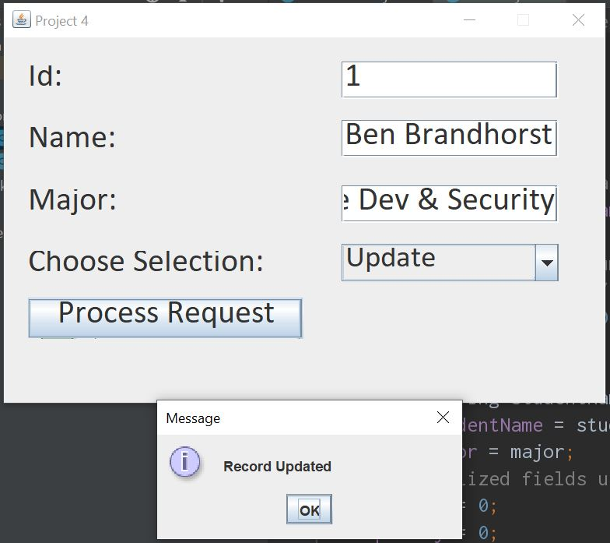

**Test Case 3 Output Example: (Find)**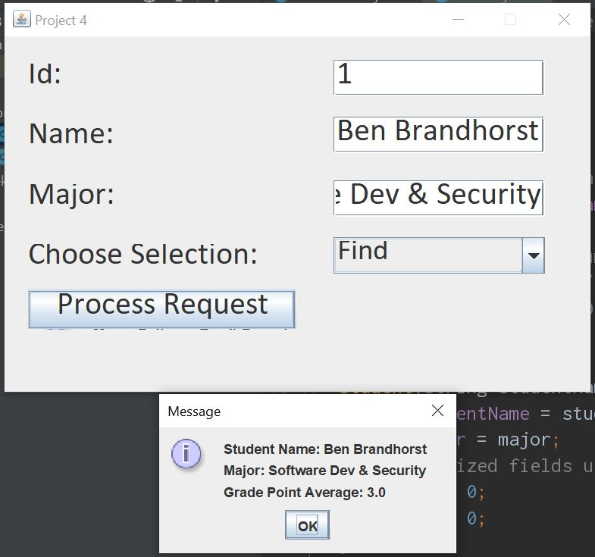

**Test Case 4 Output Example: (Delete)**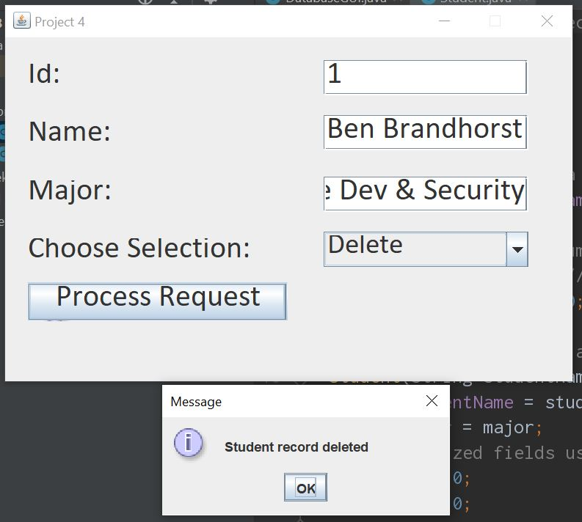

**Test Case 5 Output Example: (Non-Integer Id field input)**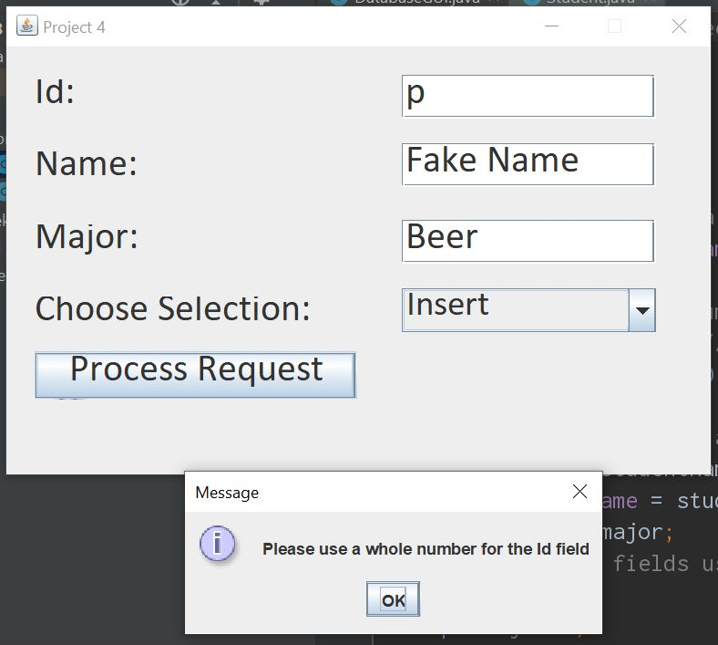

**Test Case 6 Output Example: (Attempt delete nonexistent record)**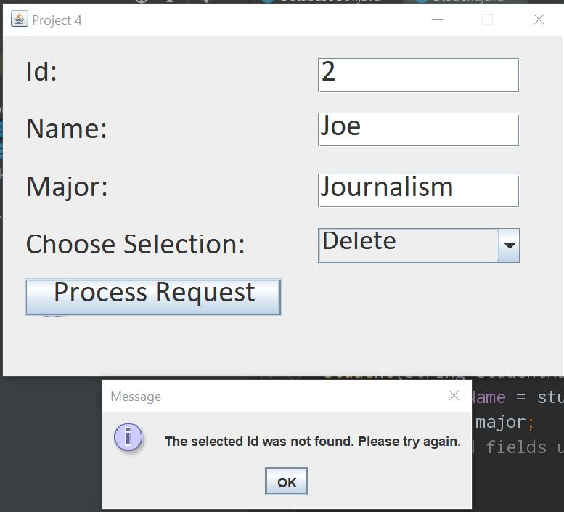

**Test Case 7 Output Example: (Attempt update nonexistent record)**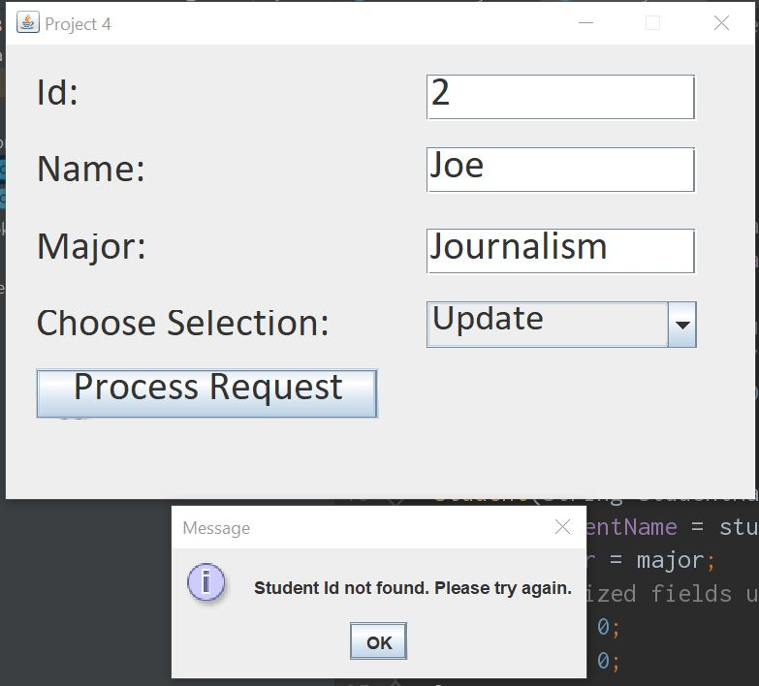

**Test Case 8 Output Example: (Attempt find nonexistent record)**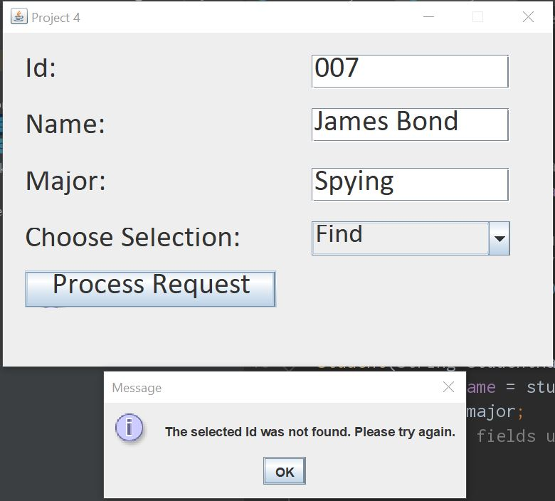

**Test Case 9 Output Example: (Attempt insert duplicate record)**